Agilent’s BioAnalyzer RNA 6000 Nano Assay

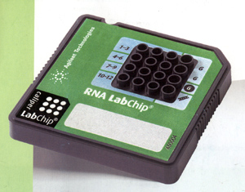 | 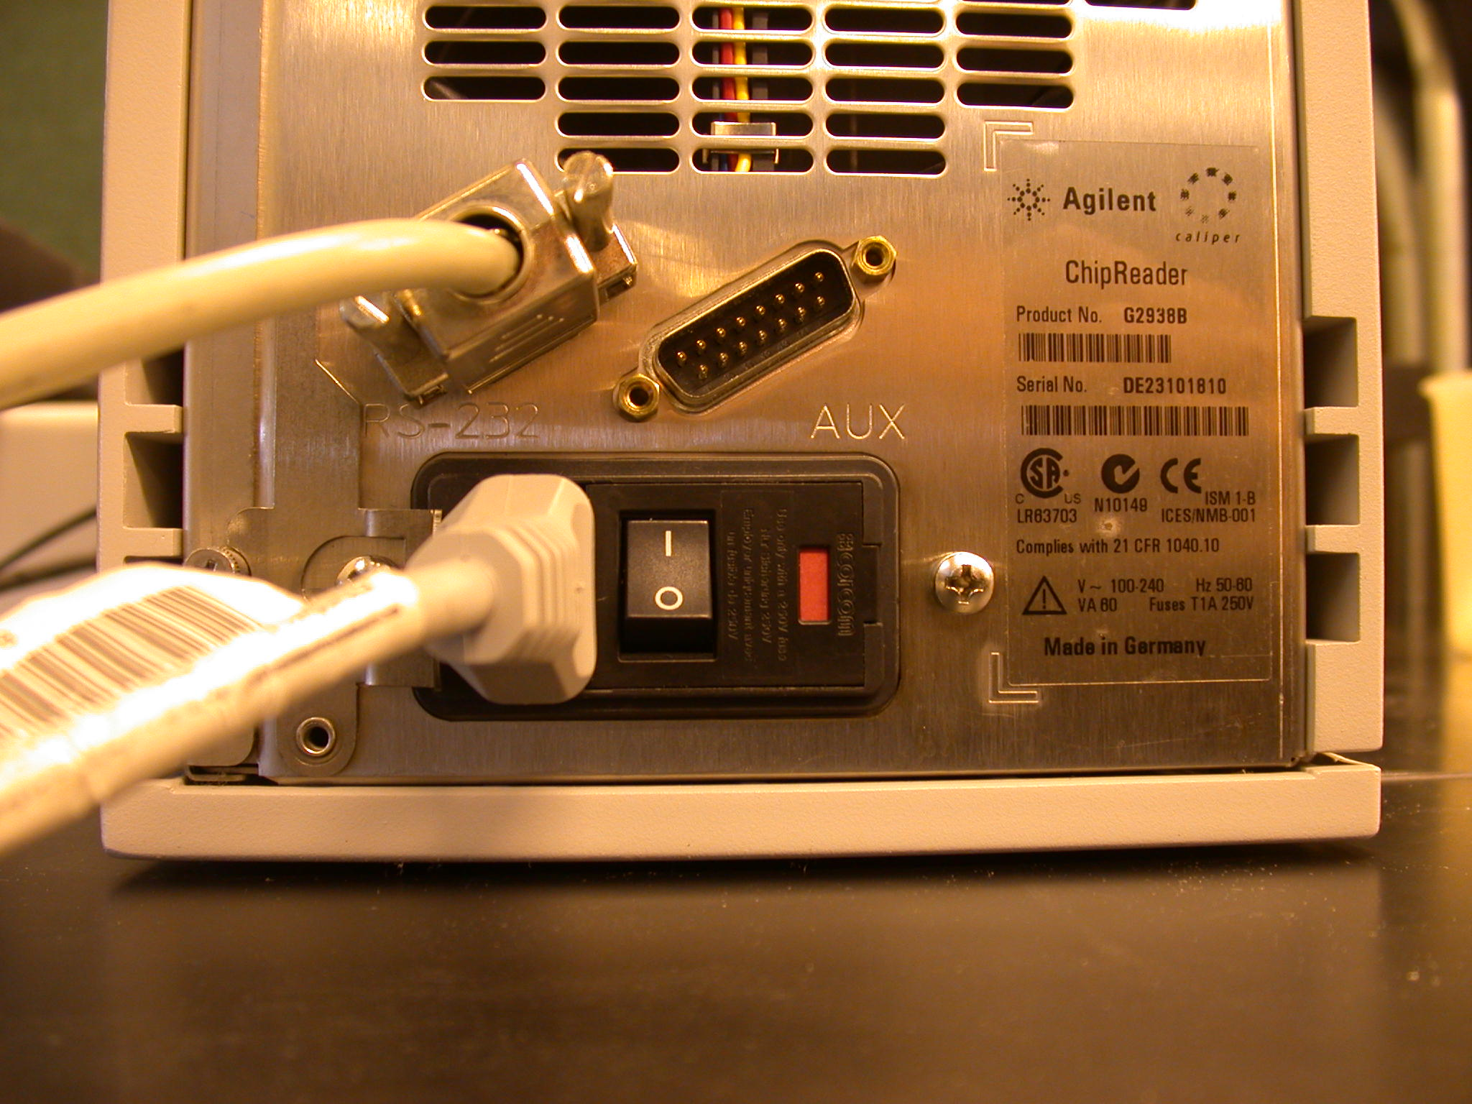
 | Location of power switch at rear of machine

1. Set up
- Login under Administrator
- Turn on BioAnalyzer (see photo above to help locate switch)
- Click on Agilent 2100 Icon to launch program
A photo of the BioAnalyzer should appear in upper left corner after 5-10 seconds.
If computer cannot find the BioAnalyzer:
Click on Tool pulldown menu
Click on Options
Click Reader tab
Scroll to COM1 and set as COM1
- Move reagents from refrigerator to room temp to warm up at least 10 min
(Reagents are kept in brown cardboard freezer box)
- Set a cleansing chip with 400ul RNAse-ZAP in chamber for 1 minute
- Remove cleansing chip and replace with water/rinse chip for 1 minute
- Remove and leave chamber open to air dry
May reuse wash/rinse solutions up to 5 times

- Prepare Gel (kept in original packaging at 4c)
Pipette 550ul Gel Matrix into spin columns supplied with the kit.
Spin 1500g for 10min.
Aliquot 65ul into 8 tubes.
Date tubes – good for several months
Store in the original packing at 4c

- Prepare Gel-Dye mix (kept in original packaging at 4c)
Pipette 65ul pre-spun gel into clean 1.5ml microfuge tube
Add 1ul RNA dye (in original packaging at 4c, has blue dot)
Cover with foil—sensitive to light
Vortex. Spin 13,000g for 10min
Store at 4c in original packaging—good for at least 4 weeks

4. Prepare RNA
Make 1:10 dilution of your RNA prep, 10ul total
Keep on ice.
Measure its concentration using the NanoDrop.
Save extra for BioAnalyzer RNA 6000 RNA Nano Assay
RNA concentration should be from 5-500 ng/ul
May store at -80 until ready for gel

Preheat your RNA samples and RNA 6000 ladder (at -80) at 65c for 2 min
Spin 14k, 30 seconds
Put on ice.

A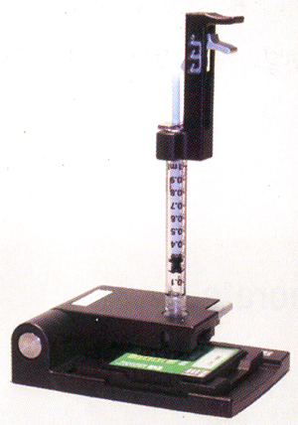 B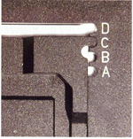 C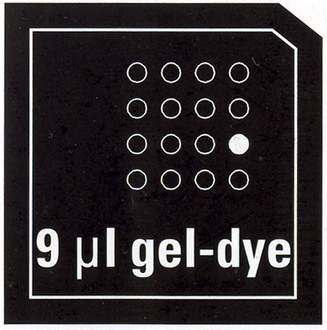 D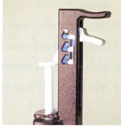

5. Load gel-dye into chip with priming station
Set timer for 30 seconds.
Place a new chip on the priming station (Figure A).
Be sure platform is at position C (Figure B)
and plunger clip is in top position (Figure D).
Pull the syringe plunger to the 1ml mark.
Pipette 9ul gel-dye mix into last well of 3rd row (marked 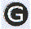 , Figure C)
Close the station (push hard!) until it clicks into place
Press the syringe until just catches under clip (Figure D).
Hit timer—goes for 30 secs
Release the clip holding the syringe—wait a few seconds until it stops moving up on its own force (if it doesn’t move at all, need to repeat).
Pull the syringe back to the 1 ml mark.
Open the station, remove chip and examine underside for bubbles

6. Fill 2 other ‘G’ wells with Gel-Dye . 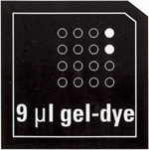 (marked G).
Pipette 9 ul gel-dye mix to the last well of row 1
Pipette 9 ul gel-dye mix to the last well of row 2

7. Fill other wells with buffer. 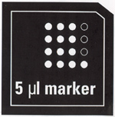
Pipette 5 ul RNA 6000 Nano Marker (Green top, comes with kit and is stored with other reagents in the original Agilent packaging) in all remaining wells. This solution is the running buffer and it contains the low molecular weight marker used to standardize all the lanes.

- Pipette Ambions RNA ladder 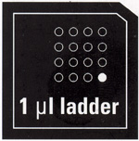 (marked  ).
Pipete 1 ul of Ambion’s RNA 6000 Ladder to the very last well of bottom row

9. Pipette 1 ul each sample to remaining 12 wells (wells 1-3 in each row). 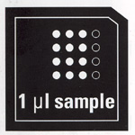
Note: if don’t have 12 samples, add 1 ul buffer (Nano Marker) to empty wells

10. Vortex chip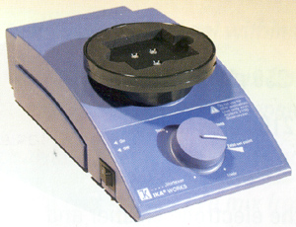
Place chip into the IKA vortexer.
Secure well with several rubber bands,
Set speed dial to the arrow and vortex for 1 minute

11. Run chip
Place chip into BioAnalyzer and close the lid carefully.
When chip is in machine and door closes, will see this screen:

(need to add screen shot)

Use default program: Eukaryotic Total RNA Nano,
or change by clicking under File

When hit START at upper right, will get this window:

File Prefix = file name—so name it something logical.
Click OK and program will start but you will also get General Chip Info window which allows you to describe your samples while the machine is going through its warm up and calibrations, etc.:

To name your samples, change Sample 1,2,3, etc to your IDs

FINISH: Remove chip from machine. Repeat wash procedures. Turn off machine.
Be sure reagents are returned to refrigerator and RNA to -80c.

Some examples
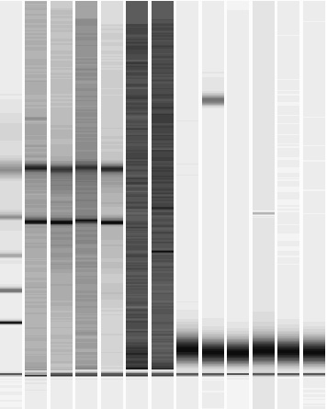 | Mammal RNA lanes 2-5.  Lanes 6 and 7 had too little sample to detect.  Other lanes had too little sample or extremely badly degraded
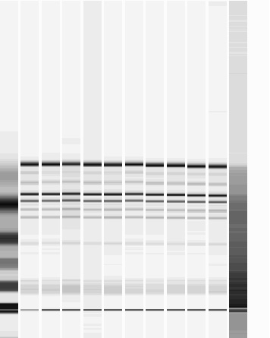 | Leaf RNA.  Marker in Lane one is unusually diffused—perhaps overloaded. The last lane has degraded RNA.
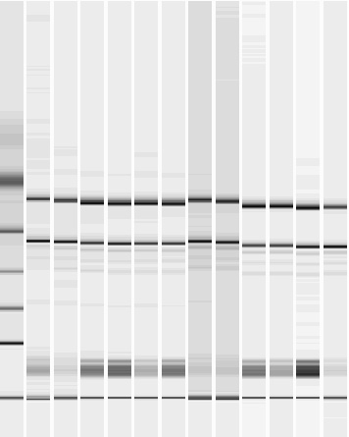 | Root RNA. Note the absence of extra bands that one sees in a leaf (photosynthetic) sample

